Long-term plan unit: Health and body |  |  | School: Aidabol secondary school
Date: |  |  | Teacher names: Mukhamedzhanova G.B.
Grade: 2A
Theme of the lesson: Our body
Learning objectives(s) that this lesson is contributing to |  | 2.S3 use a limited range of basic words, phrases and short sentences to describe objects, activities and classroom routines  2.R4 begin to use with support a simple picture dictionary  2.W3 write short phrases to identify people, places and objects
Lesson objectives |  | All learners will be able to:
- Use phrases and show actions
- Apply a picture dictionary
- Complete short phrases
Level of thinking |  | Application
Value links |  | Cooperation Respect: they will learn to be polite and respectful to each other
Cross curricular links |  | Biology
ICT skills |  | PPT, computer
Plan
Planned timings | Planned activities (replace the notes below with your planned activities) |  |  |  | Resources
Beginning  3 min | Greeting, Warm Up [W]  T: Greet the students. Sing the song  T: Stand up one by one, speak and show the actions  "Hello! Hello!".  How are you? How are you?  I'm fine  I'm great 2 times  I'm wonderful  The teacher and students together sing the song:  Cl: Hello, hello!  How are you? How are you?  S1 – I’m fine  S2 – I’m great  S3 - I’m wonderful  All students sing a song and sit on their seats |  |  |  | Sing the song  "Hello! Hello!".
7 min | Pre- learning  Our theme about "Our body"  Task 1 [W] T-S1-S2- S3  What will do today?  Aim 1 Use phrases and show actions  Aim 2 Use a picture dictionary  Aim 3 Complete short phrases  You studied this subject in the 1st grade. I show pictures and they must remember a body part. I start the lesson with the PPT with vocabulary on it and drills pronunciation and words. Then ask learners for a little short competition to show you the cards as you recall them. At the end of the lesson, the students can show 4 moves, and use basic words to practice  T: What is this?  S: It is an eye.  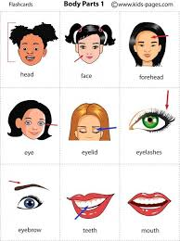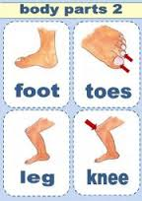 |  |  |  | PPT or cards to be used
Middle  3-4 min | Task 2. [[P]S1-S2. Students work in pairs with early reading and then associates the appropriate words to images.  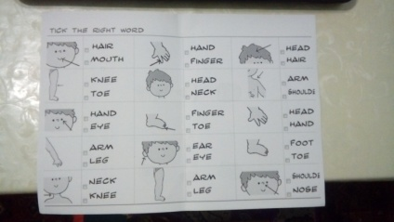  (Peer assessment) (Assesses him\herself according to the assessment criteria)  Feedback: S1-S2 (what words knows his partner and what words to repeat)  Criteria Descriptors  Students read and associate the appropriate words 1. Ss reads 2. ticks right words 3. identifies parts of body |  |  |  | Worksheet 1
5 min | Task 3 [I] T-S1, T-S2  Differentiation by task in the book  T: Teacher gives different tasks for learner.  Low level learners filling the missing letters correctly, draw, colour and say parts of the body.  mouth  ear  nose  foot  hand  eye  High level learners copybook ex 1 p 36 using picture dictionary find parts of the body  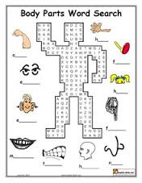  (Self- assessment) As this is an individual task. I post the correct answers on the board and the students assess themselves, for each correct answer put 1 point.  Criteria Descriptors  Find and write words from picture 1. to pronouns clearly 4 phrases: (clap, move, touch, stamp) 2. to show clearly 4 phrases: (clap, move, touch, stamp) |  |  |  | Work-sheet 2
1 min  4 min | T: Warm up: Teddy bear  Speaking: [I] children speak about your toys
6-8 min | Task 4 [W] T-S1-S2-S2-S1 TPR - active learning  Modelling: Т- touch your eyes  S1- does the action  S1- stamp your feet  S2- does the action  T: To revise body parts and actions people do with them, this activity is organized. To teach children the 4 actions they can do by submitting them. Try some of the actions and to train them in practice: to touch, to move, to clap and stomp. Then the students played the entire class to show each other these 4 movies  (Peer assessment)Appreciate each other (If the answer is correct they clap and give red, yellow stars)
1 min | Feedback  For example: he showed the phrase close your eyes but could not show stomp your feet.  S1 shows those actions which are not knows S2
5-7 min | Home task  Task 5 [I, W] T-S1\ S2- S1  Copybook ex 2 p 36  Read and colour  All learners according by instructions draws the monster  Criteria Descriptors  Use picture dictionary Complete short phrases - to draw a monster according to the instructions; - name the colors and body parts |  |  |  | Work-sheet 3  Coloring page
End  5 - 6 minutes | [L.S] T-S1-S2  Plenary: Learners have to close their eyes and touch \ wiggle \ shake \ etc. their body parts. I make up notes on the progress.  Reflection: Ask learners what they have learnt and what was still difficult. Ask them to show their fingers to assess their progress.  Home task: complete the worksheet and draw a monster with description.
Feedback  3 min | Can do list? T-S [W]  Run to can\can't (with commands)  T: Can you speak all the names body?  S: Yes, I can.  T: Can you show (clap, close, touch, stomp)  S: Yes, I can.
Reflection  2 min | "Flowers"  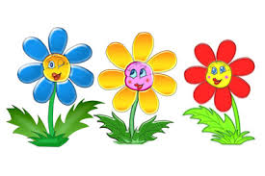  Blue flower- I know all parts of body.  Yellow flower - I can do actions.  Red flower - I learn the parts of body and do the actions.

